Title of the Event | Talk on Women’s Health | 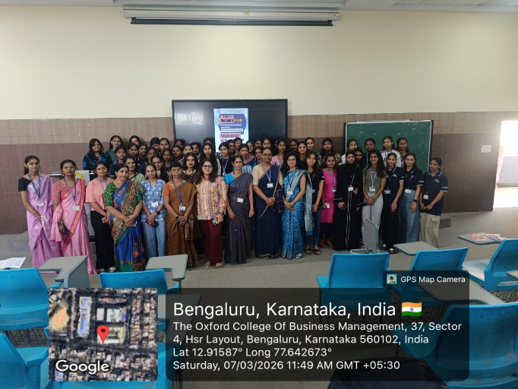
Day and Date | 7 March 2026
Venue (With all details ) | Room No- 407
In collaboration with ( if any) | Natus Women and Childre Hospital
Details of Resource Person With Designation | Dr. Gauthami M, Consultant Obstetrician and Gynecologist | 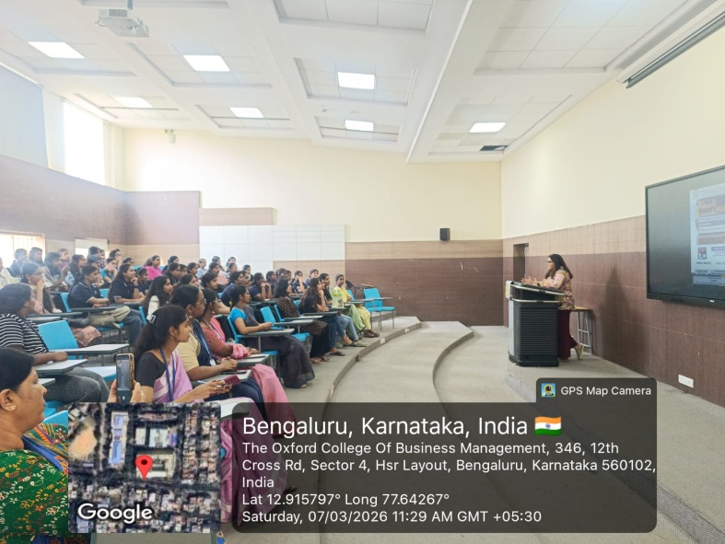
Organizing Department/Coordinators | Commerce and Management ,
Course and semester | Famel faculties and Female students of UG, PG Management
No of Students & Faculty Participants | 50

Coordinator HoD Vice-Principal Principal

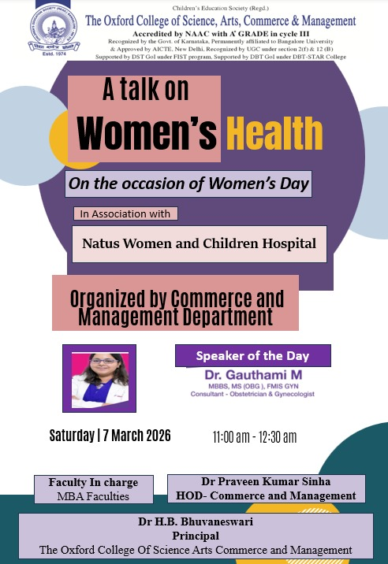
Introduction
On the occasion of International Women's Day, the Department of Commerce and Management organized a talk on “Women’s Health” on 7 March 2026 in association with Natus Women and Children Hospital. The session was delivered by Dr. Gauthami M, Consultant Obstetrician and Gynaecologist (MBBS, MS – OBG, FMIS GYN), with the objective of creating awareness about important health issues faced by women.
Description of the Activity
The session was conducted for UG, PG students and focused on various aspects of women’s health and well-being. Dr. Gauthami M explained important topics such as menstrual health, reproductive health, preventive care, and common gynaecological issues faced by women. She also emphasized the importance of regular health check-ups, healthy lifestyle practices, and early diagnosis of health problems. The session was informative and interactive, where students actively participated and clarified their doubts regarding women’s health awareness and preventive measures.
Outcome of the Activity
The session helped students gain better awareness about women’s health and the importance of maintaining physical and reproductive well-being. It also encouraged students to understand the significance of health education and preventive healthcare practices.
Conclusion
The Women’s Health talk was a meaningful initiative by the Department of Commerce and Management. The session successfully created awareness among students about important health issues affecting women and highlighted the need for proper health care and awareness in society.

